**CSYE 7245 - Big-Data Systems and Intelligence Analytics**

**MakeMyTrip**

<https://www.kaggle.com/PromptCloudHQ/hotels-on-makemytrip/>

**Abstract**

This is a pre-crawled dataset, taken as subset of a bigger dataset (more than 615,000 hotels) that was created by extracting data from MakeMyTrip.com, a travel portal in India.

**Introduction**

In this project using the data collected by Kaggle for MakeMyTrip, we are going to determine the hotel rating using

* Facilities provided by each hotel.
* Type of rooms available in each hotel.

Higher the count of the above two column, higher is the rating.

So for example 1 hotel is providing facilities like [ Airport Transfer, Car rental, Conference Hall, Currency Exchange, Doctor on Call, Dry Cleaning, Guide Service, Internet access, Jungle Safari, Laundry Service, Restaurant, Room Service, Wi-Fi Internet] which totals up to 13. Similarly, we will count types of rooms.

There is a more accurate way of doing it, we can split each value of the columns and then plot a ‘Yes’ and ‘No’ table for each row. This method would have given a better prediction but it requires a lot of computation power to execute it.

**Code with Documentation**

We need to import the data set in notebook and then start removing the unnecessary data and columns.

Below we are importing dataset and cleaning it

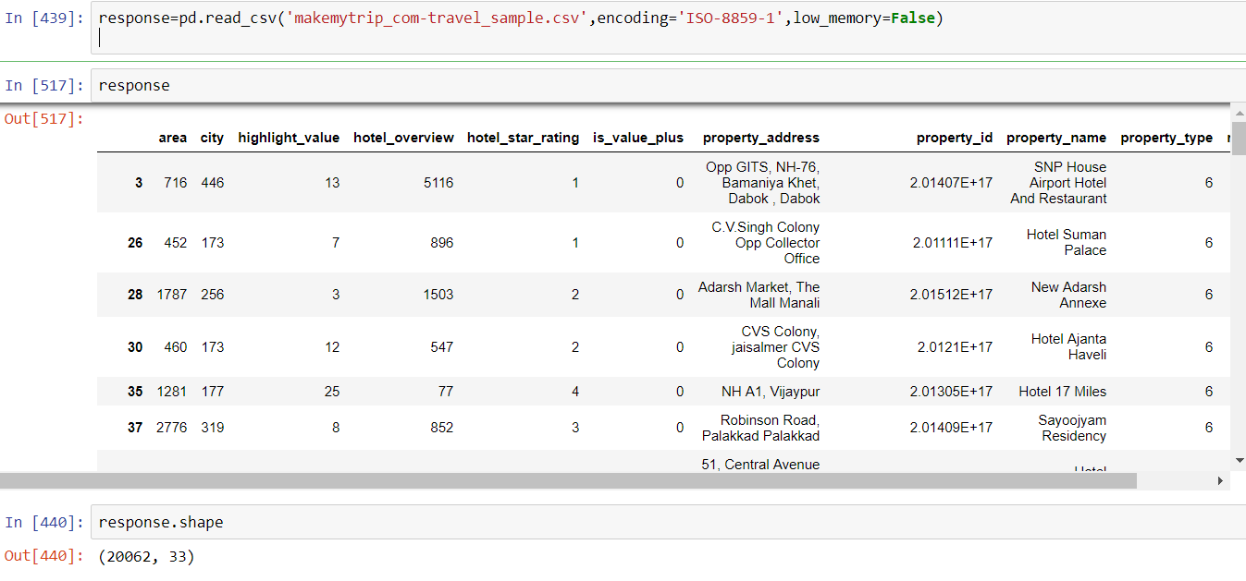

Here we check for sum of null values and then delete unrelated rows from our dataset.

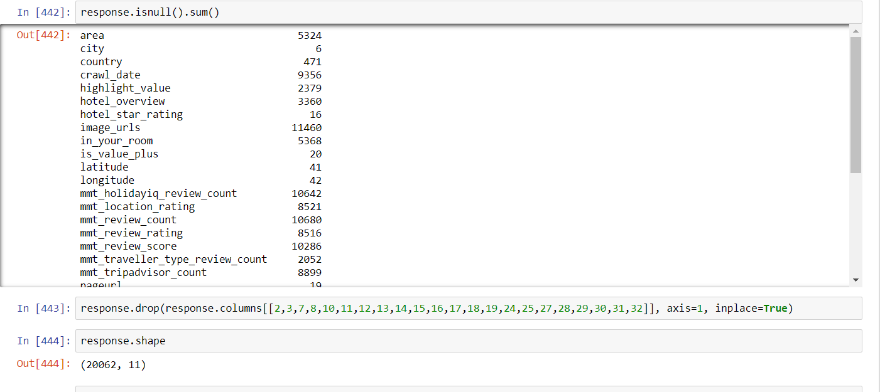

For cleaning a particular column, we need check unique value of that column. For hotel_star_rating , some value of row was 1 star, 2 start, 3, 5, 1. So we need to make it follow a standard representation i.e. integer. In the below code we are removing ‘star’ from each cell and the blank spaces.

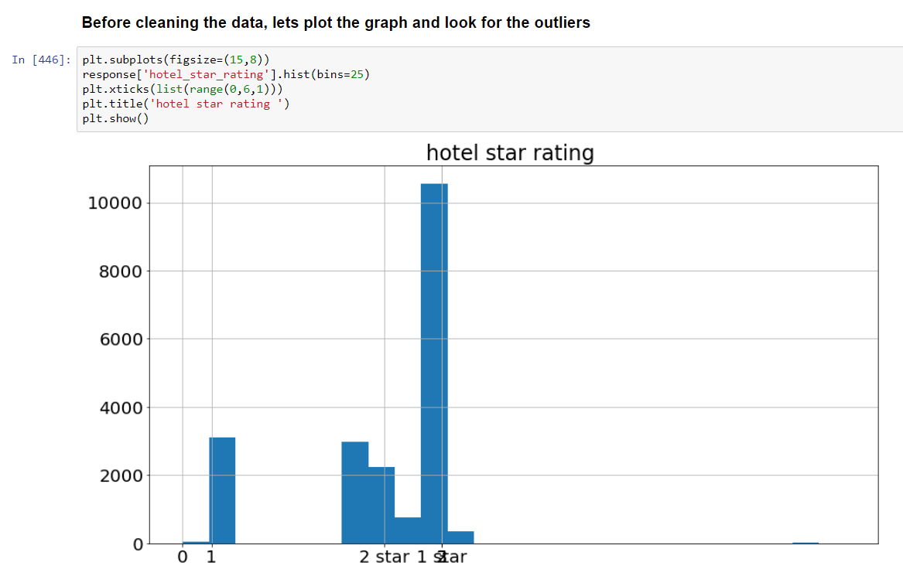

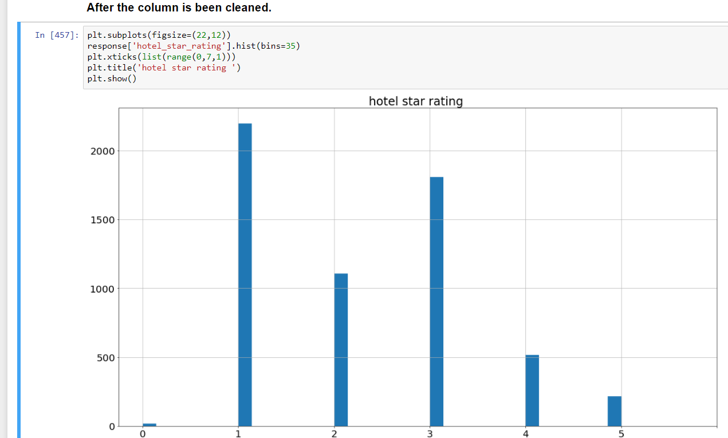

**Exploring some data that has the highest number of reviews.**

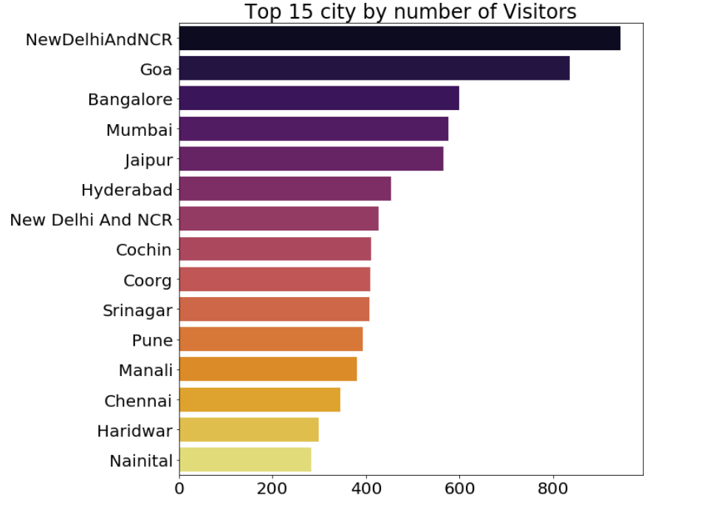

**Results**

**Discussion**

**References**

<http://www.pythonforbeginners.com/loops/for-while-and-nested-loops-in-python>

<https://stackoverflow.com/questions/5278122/checking-if-all-elements-in-a-list-are-unique/5281641>

<https://www.kaggle.com/ash316/novice-to-grandmaster>

<https://stackoverflow.com/questions/28538536/deleting-multiple-columns-based-on-column-names-in-pandas>

<https://www.dataquest.io/blog/jupyter-notebook-tips-tricks-shortcuts/>